

American International University-Bangladesh (AIUB)  
**Department of Computer Science  
Faculty of Science & Technology (FST)**

**PROJECT TITLE**

A Software Engineering Project Submitted

By

|  |  |  |  |  |
| --- | --- | --- | --- | --- |
| **Semester: Summer 24-25** | | **Section:** | **Group Number:** | |
| **SL** | **Student Name** | **Student ID** | **Contribution (CO3+CO4)** | Individual Marks |
| 1 | Mahbub Hasan | 22-47419-2 | 25% |  |
| 2 | Mujtahid Tabassum Mohona | 22-47430-2 | 25% |  |
| 3 | MD. Zobayer Hosen | 23-50348-1 | 25% |  |
| 4 | MD. Tauhidul Islam | 22-49388-3 | 25% |  |
| 5 |  |  |  |  |

The project will be evaluated for the following Course Outcomes



|  |  |  |
| --- | --- | --- |
| ***CO3 (PO-g-1)***  ***Select appropriate software engineering models, project management roles and their associated skills for the complex software engineering project and evaluate the sustainability of developed software, taking into consideration the societal and environmental aspects*** | Total Marks | |
|  | |
| Selection of Software Engineering Models: Process model selection and presents sufficient evidence to support argument for the model selection | [5 Marks] |  |
| Role identification and Responsibility Allocation: Well-planned project with proper role identification and responsibility allocation in the project management activities | [5Marks] |  |
| Formatting and Submission: Submission, Defense, Completeness, Spelling, grammar, and Organization of the Project report | [5Marks] |  |
| Impact identification: Analysis of the impact of societal, health, safety, legal, and cultural issues | [5Marks] |  |
| ***CO4 (PO-k-1)***  ***Apply engineering management principles and economic decision making to develop software engineering project management plan.*** | Total Marks | |
|  | |
| Project WBS and Testcases: Relevant WBS (project task list) and testcases for the proposed project are stated properly. | [5Marks] |  |
| Effort Estimation and Scheduling: Project estimation was described using proper effort estimation or schedules based on available project resources | [5Marks] |  |
| Risk Management: Sufficient and appropriate risks are identified, analyzed, and properly categorized or prioritized. | [5Marks] |  |



# PROJECT PROPOSAL

## Background to the Problem

Healthcare access in Bangladesh, especially in Dhaka, is often challenging due to overcrowded hospitals, traffic congestion, and limited availability of doctors at the right time. Patients often face long waiting times to book appointments, and sometimes they have to travel long distances for basic diagnostic tests or to rent medical equipment. This delay can affect timely diagnosis and treatment. Moreover, there is no centralized platform for patients to easily find doctors, book appointments, order tests at home, or rent medical resources.

At the same time, hospitals and diagnostic centres face difficulties in managing patient requests efficiently. Doctors also have limited tools to communicate with patients, manage appointments, or share health information securely. Existing solutions in Bangladesh are either fragmented or limited in scope, such as booking platforms for only appointments without including lab tests, equipment rental, or home services. Hence, there is a strong need for a comprehensive healthcare management system that connects patients, doctors, and hospitals in a single, reliable platform.

## Solution to the Problem and Process Model Selection

**Project Scope and Features**

This project is a healthcare management software for Bangladesh, especially Dhaka city, where patients, doctors, hospitals, and admins can connect through one platform.

**Scope includes:**

**Patient Side:** Appointment booking, serial tracking, cancel, upload reports, order home tests, rent hospital cabins/ambulances/equipment, read blogs, chat with AI Doctor.

**Doctor Side:** Manage profile (time, fee, qualifications), write blogs, cancel patient serial, view ratings, chat with patients.

**Hospital Side:** Manage tests, cabins, ambulances, and medical equipment (CRUD), accept/reject requests, check ratings.

**User Story Table**

|  |  |  |  |  |
| --- | --- | --- | --- | --- |
| **ID** | **As a…** | **I want to…** | **So that…** | **Priority** |
| US-01 | Patient | Search for nearby doctors by specialty | I can book an appointment easily | High |
| US-02 | Patient | Upload reports for doctor | They can review before my visit | High |
| US-03 | Patient | Order home diagnostic test | I can get my report without going outside | High |
| US-04 | Patient | Book/rent cabin, ambulance, equipment | I can get service from home | Medium |
| US-05 | Patient | Chat with AI Doctor | I can get early guidance and doctor suggestion | Medium |
| US-06 | Doctor | Set my profile with fee, time, and address | Patients can see accurate info | High |
| US-07 | Doctor | Cancel appointment if needed | I can manage my schedule | High |
| US-08 | Doctor | Write health blogs | Patients can learn from me | Medium |
| US-09 | Hospital | CRUD for tests, cabins, equipment | Patients see updated info | High |
| US-10 | Hospital | Accept/reject patient requests | I can control my resources | High |
| US-11 | Admin | Monitor users and see monthly signup stats | I can track platform growth | High |
| US-12 | Admin | Create, update, delete user accounts | I can manage the system effectively | High |

**User Story Board (Trello)**

**Backlog in Trello:**

**Existing Software Solutions**

**Practo (India based)**: Appointment booking, but not fully for Bangladesh.

**Doctorola (Bangladesh)**: Limited to doctor appointment booking only.

**Sheba Platform**: Provides some home services, but not fully integrated with doctors, hospitals, and equipment.

**Hospital Internal Systems**: Used inside hospital but not patient-friendly mobile apps.

**Gap:** None of these provide **one full ecosystem** for patients, doctors, hospitals, and admins in Bangladesh context. Our system will solve that.

**Process Model Selection: Agile Scrum**

We will use the **Agile Scrum** model. This is because requirements are not fully stable. Patients, hospitals, and doctors may give feedback after each release, and we must update quickly.

**Why Agile Scrum is suitable:**

**Iterative development:** We can release core features (appointment booking, test order) first, then add advanced ones (AI chat, ambulance rental).

**Team communication:** Daily Scrum meetings help developers, testers, and designers stay on the same page.

**Flexibility:** Scope can be changed or extended sprint by sprint.

**Risk management:** If something fails in one sprint, we can fix in next sprint without big loss.

**Timely delivery:** Each sprint (2 weeks) delivers working features to real users.

**Analysis of Project Environment**

**Requirements:** Partly stable (appointment booking, user management) and partly changing (AI Doctor, chat features).

**Users:** Patients and hospitals in Dhaka may ask for more features after launch.

**Technology:** Using mobile apps + backend APIs. Future updates may require AI integration.

**Market environment:** High demand in Dhaka due to long queues in hospitals and busy traffic.

**How Agile Scrum Supports Team and Business Objective**

**Team Size:** Small(4 people). Scrum allows clear role distribution (Product Owner, Scrum Master, Developers, Testers).

**Communication:** Daily standups and sprint retrospectives ensure smooth task flow.

**Feasibility:** By delivering MVP first (appointments, test order), we can achieve business goals quickly and show value to investors/hospitals.

**Flexibility of Scrum**

Easy to adapt new features like online payment, telemedicine, or insurance integration.

If hospitals want new reporting features, it can be added in next sprint.

If patient feedback suggests UI changes, those can be applied quickly.

**Creative and Real-Life Solution Insight**

Our solution will save patients in Dhaka from wasting hours in traffic to just book an appointment or get a test. A patient sitting at home can order a test, get report online, and book the right doctor based on AI suggestions. Hospitals will reduce manual management workload. Doctors will gain visibility and better patient engagement.

By connecting **patient + doctor + hospital + AI support** in one platform, this project creates the first **all-in-one digital healthcare ecosystem for Bangladesh**.

**Contribution to scientific results**

Our project will contribute to scientific results in healthcare technology in Bangladesh. By collecting and analyzing real usage data, such as patient waiting time, number of appointments, test orders, and ambulance requests, we can identify patterns and challenges in Dhaka’s healthcare system. These data points can later be anonymized and documented to support future studies on urban healthcare access. In addition, our integration of an AI-powered assistant for basic health guidance will allow researchers to measure how artificial intelligence can improve early health decision-making in a developing country context. All findings will be documented in reports, technical papers, and datasets that can be reused for further scientific study.

**Evidence for model selection**

The Agile Scrum model is the most effective choice because of the nature of our problem and environment. In Dhaka, hospitals and patients may not fully know what they want until they see a working solution. Scrum allows us to deliver small usable features quickly, gather feedback, and make improvements without waiting for the entire system to be finished. This early delivery reduces risk and ensures stakeholders stay engaged. Evidence from many healthcare IT projects worldwide shows that iterative models like Scrum are more successful than rigid models when user needs are evolving. Thus, there is strong argument that Scrum is the right fit for our proposed solution.

**Managing project risks and uncertainties**

The Scrum model is highly effective in managing risks at different stages. In the early stage of the backlog, risks of unclear requirements are handled by refining stories with stakeholders. During development sprints, risks such as integration problems or low code quality are reduced through daily standups, code reviews, and automated testing. At the sprint review, stakeholders can identify risks of usability or acceptance, which are then fixed in the next sprint. This step-by-step approach ensures that risks are discovered early and solved before they become large problems.

**Relation to project schedule**

Scrum directly supports project scheduling by using fixed-length sprints. For example, in our project we may choose two-week sprints, meaning every two weeks we can deliver a working increment. This keeps the team focused and ensures that deadlines are respected. Even if the final scope changes, we will always have working software at the end of each sprint. For Dhaka healthcare providers, this means they can test and use features like booking or test ordering much earlier, rather than waiting for the whole platform to be finished. This predictable schedule also allows the management team to plan pilot launches on time.

**Justification against other models**

Other process models were considered but found less suitable. The Waterfall model requires fixing all requirements at the start, which is unrealistic in Dhaka’s healthcare environment where hospitals and patients often change their needs after trying the system. V model is good for risk management but is too complex and resource-heavy for our small team. Scrum provides the right balance between flexibility, team coordination, and timely delivery. Therefore, compared to other models, Scrum is the most practical and effective approach for this project.

**Final justification**

In summary, our choice of Scrum is justified by clear evidence and alignment with the real environment of Bangladesh. It helps us adapt to changing needs, manage risks step by step, and deliver working results in short time frames. It ensures patients, doctors, and hospitals in Dhaka see early value and can guide the project direction. It also supports research contributions by documenting data and outcomes along the way. No other process model offers this strong balance of adaptability, stakeholder involvement, and predictable scheduling, making Scrum the best approach for developing our healthcare management system.

## Project Role Identification and Responsibilities

**Main Roles Involved**

Our project team will follow Agile Scrum roles along with additional technical roles to ensure smooth development and management. The main roles include:

* Product Owner
* Scrum Master
* Development Team (Frontend Developer, Backend Developer, Mobile App Developer, Database Engineer, AI Engineer)
* UI/UX Designer
* QA Tester
* System Administrator / DevOps Engineer

**Responsibilities in Key Stages**

**Requirements Gathering:** The Product Owner will collect requirements from stakeholders (patients, doctors, hospitals). The Scrum Master ensures the backlog is clear. Developers and designers may also give input during backlog refinement.

**Design:** The UI/UX Designer prepares mockups and wireframes. The Backend and Database Engineer design the system architecture. The Product Owner validates design decisions with stakeholders.

**Implementation:** The Frontend, Backend, Mobile App developers write the code. The Scrum Master ensures sprint progress.

**Testing:** The QA Tester checks functionality, performance, and security. Developers also do unit testing. The Product Owner validates features against acceptance criteria.

**Deployment:** The System Administrator/DevOps Engineer manages deployment to server or cloud. The Scrum Master ensures release is aligned with sprint goals.

**Decision Making, Quality Assurance, and Resource Management**

Decision Making: The Product Owner makes final decisions on features and priorities. Technical decisions are shared among the development team with the Scrum Master facilitating.

Quality Assurance: The QA Tester is directly responsible, but all developers must follow coding standards. The Scrum Master ensures quality checks are done each sprint.

Resource Management: The Scrum Master manages time and team resources, while the System Administrator manages technical resources like servers, databases, and cloud infrastructure.

**Distribution of Responsibilities and Justification**

**Product Owner** is chosen because they have domain knowledge of Bangladesh healthcare and can speak directly with patients, doctors, and hospitals.

**Scrum Master** is allocated to someone skilled in team coordination and Agile process management.

**Frontend & Mobile Developers** are responsible for building patient, doctor, and hospital apps because of their expertise in MERN and mobile frameworks.

**Backend & Database Engineers** handle APIs, databases, and integrations because they have strong system design knowledge.

**AI Engineer** focuses on the AI Doctor feature since it requires special expertise in machine learning and NLP.

**UI/UX Designer** ensures that the app is simple enough for Bangladeshi users who may not be very tech-savvy.

**QA Tester** ensures features meet requirements before release.

**System Administrator / DevOps Engineer** manages deployment pipelines and keeps the system online 24/7.

## 2. SOFTWARE REQUIREMENTS SPECIFICATIONS (SRS) / PRODUCT REQUIREMENTS DOCUMENT (PRD)

## 2.1 Functional Requirements

**Patient User Role:**

|  |  |  |  |  |  |
| --- | --- | --- | --- | --- | --- |
| Item No. | Feature | Specification | User Story | Screen Definition | Acceptance Criteria |
| 1 | Welcome Screen | Splash Screen | As a user, I want an engaging splash screen while the app loads. | Splash screen with logo during app startup | Blue background splash screen with centered logo. Display for 2s minimum or until DOM loads. Clear branding on app launch. |
| 2 | Onboarding | Swipe Animation with Information | As a first-time user, I want to learn about the app through an informative carousel. | First-time user carousel with app introduction | Three-slide carousel for first-time users with headings and images. 'Get Started' button on final slide saves cookie to prevent re-display. |
| 3 | Authentication | Login or signup | As a user, I want to easily sign in or create an account with multiple options and secure verification. | Login/signup screen with social media and email options | Login options: Gmail, Facebook, email/password. 'Forgot Password' link. Signup form with email, password (8+ chars), name, phone. OTP verification via email. |
| 4 | Profile Setup | Upload profile picture | As a new user, I want to optionally add a profile picture to personalize my account. | Profile picture upload during onboarding | Profile setup screen after registration. Upload profile picture option with skip functionality. Accepts JPEG/PNG formats. |
| 5 | Profile Setup | User basic information entry | As a new user, I want to provide basic information or skip to continue using the app. | Additional profile information collection | Basic information form: gender, age, address. Skip option available. Data saved to user profile. |
| 6 | Location Service | Location permission or manual selection | As a user, I want to share my location for relevant local healthcare information. | Location access for personalized content | Location permission prompt or manual map selection. Homepage inaccessible until location provided. Location-based content display. |
| 7 | Search | Search bar with filtering | As a user, I want to search and filter healthcare services to find what I need quickly. | Homepage search with filtering capabilities | Search bar for doctors, hospitals, tests with real-time results. Filter button with options: doctor name, hospital, disease type, specialist, test name. |
| 8 | Content Discovery | Popular healthcare carousel | As a user, I want to see popular healthcare options in my area for quick selection. | Carousel displaying popular local healthcare options | Location-based carousel below search bar showing popular hospitals, services, doctors, tests. Swipeable navigation with clear labels. |
| 9 | Favorites | Favorite items functionality | As a user, I want to save preferred healthcare options for easy future access. | Favorite marking system for healthcare items | Love icon on each carousel item. Click to favorite and save to profile. Visual indication for favorited items. SQLite3 storage. |
| 10 | Content Navigation | Complete service listings | As a user, I want to see comprehensive lists of healthcare options in each category. | Full list view for each healthcare category | 'View All' button in each carousel section. Redirects to complete location-based list of hospitals, services, doctors, or tests. |
| 11 | Navigation | Home Screen navigation | As a user, I want easy navigation between different app sections. | Main navigation between app sections | Navigation bar with Home, Reviews, Blogs, Account icons. Home icon navigates to location-based content and services carousel. |
| 12 | Health Management | Medicine Reminder system | As a user, I want to manage medicine reminders with flexible scheduling options. | Medicine reminder with alarm functionality | Alarm-style medicine reminder interface. 'Add New' popup for time, weekdays, duration, snooze settings. Long-press for edit/remove options. Toggle on/off. |
| 13 | Content | Blog Page with engagement | As a user, I want to read health articles and engage with content through comments and reactions. | Health blog platform with interaction features | Blog list with clickable titles. Category filter bar. Sort by date or doctor name. React to posts and comment. Reply to comments. |
| 14 | AI Service | AI Doctor chat | As a user, I want to consult an AI doctor and access my conversation history. | AI doctor consultation chat interface | GPT-like chat interface with AI doctor. Side panel shows chat history. Real-time health advice responses. |
| 15 | Account Management | User profile management | As a user, I want to manage my profile information and account settings. | User profile editing and account control | Profile management: edit name, password, email, phone, address, picture. Email/phone changes need OTP verification. Account delete/deactivate options. |
| 16 | Order Management | Order History access | As a user, I want to view my service history and easily reorder or review past services. | Past service usage tracking | Order history list with dates. Review button and 'Place Again' option for each service. Clear chronological display. |
| 17 | Appointment Tracking | Track Appointment details | As a user, I want to track my appointment status and waiting times. | Current appointment status monitoring | Scheduled appointments list with date, serial number, estimated wait time, running serial. Real-time updates. |
| 18 | Service Management | Active Orders monitoring | As a user, I want to monitor my active rental services and their status. | Current rental service tracking | Active rental bookings (ambulance, oxygen, cabin) with status, duration, service details. Real-time updates. |
| 19 | Navigation | Navigation history stack | As a user, I want intuitive navigation with swipe gestures and history tracking. | Page navigation history and gesture controls | Navigation history stack. Swipe left/right navigation. Back button on each page. iOS gesture support. Session persistence. |
| 20 | Payment Processing | Payment Option selection | As a user, I want flexible payment options appropriate for different healthcare services. | Service-specific payment method handling | Payment options: mobile banking, card, bank payment for all services. Cash-on-hand for appointments, ambulance, oxygen. Advance payment only for cabins. |
| 21 | Review System | Doctor/hospital reviews | As a user, I want to rate and review healthcare providers to help others make informed decisions. | Healthcare provider feedback and rating system | Doctor/hospital profile pages with rating and comment sections. 1-5 star ratings with text comments. Public feedback display. |
| 22 | Provider Information | Doctor/hospital profile display | As a user, I want detailed information about healthcare providers to make informed choices. | Detailed healthcare provider profiles | Tap doctor/hospital cards to view profiles. |

**Doctor User Role:**

|  |  |  |  |  |  |
| --- | --- | --- | --- | --- | --- |
| Item No. | Feature | Specification | Screen Definition | User Story | Acceptance Criteria |
| 23 | Doctor Profile | Doctor profile header with picture and name | Welcome page with doctor's basic information display | As a doctor, I want my profile and name visible on the welcome page to confirm correct account access. | Profile picture and full name prominently displayed in header. Reliable image loading without errors. Name matches logged-in account exactly. |
| 24 | Patient Feedback | Patient comments management with ratings | Recent patient comments with detailed view and reply options | As a doctor, I want to see and respond to patient feedback to manage my reputation and improve service. | Display 3-5 recent comments by default. 'View All' button expands to complete feedback history. Reply button on each comment opens text input. Rating breakdown by categories. Load within 2 seconds. |
| 25 | Appointment Management | Serial appointment request handling | Patient appointment requests with approval controls | As a doctor, I want to review and manage appointment requests to control my schedule effectively. | Show appointment requests with patient name, date, time. Accept/Reject buttons process immediately. Auto-notify patients of doctor's decision. 'View All' shows complete history. |
| 26 | Navigation | Welcome page navigation shortcuts | Quick access icons for key doctor features | As a doctor, I want quick access to important features for efficient navigation between sections. | Welcome icon redirects to homepage. Quick-access buttons for account, reviews, blog management. All buttons respond within 1 second of click. |
| 27 | Account Management | Account settings and profile updates | Doctor account options and profile management | As a doctor, I want to manage my account details and control my visibility and security settings. | Profile editing with auto-save and confirmation. Account delete/deactivate requires password confirmation. Hospital listing request with pending status. Logout redirects to login screen. |
| 28 | Review Management | Reviews tab with filtering capabilities | Patient reviews with filtering and display options | As a doctor, I want to view and filter patient reviews to track performance and satisfaction levels. | All reviews load within 2 seconds. Filter by 1-5 star ratings and comment keywords. Display reviewer name, date, star rating, full comment. Filter results show under 0.5s delay. |
| 29 | Content Management | Blog page with post editor | Blog post creation and management interface | As a doctor, I want to create and manage blog posts to share medical knowledge with patients. | 'Add New' button opens blank editor. Tap-and-hold reveals Edit/Delete options. Auto-save drafts every 10 seconds. Published posts appear instantly in listing. |
| 30 | Patient History | Patient visit history tracking | Chronological patient visit history with search functionality | As a doctor, I want to view patient visit history to track consultations and enable follow-ups. | Display 50 recent visits by default. Show patient name, visit date/time, consultation reason. Real-time search by name/date under 500ms. Complete history loads within 3 seconds. |

**Hospital User Role:**

|  |  |  |  |  |  |
| --- | --- | --- | --- | --- | --- |
| Item No. | Feature | Specification | Screen Definition | User Story | Acceptance Criteria |
| 31 | Hospital Profile | Hospital profile header with picture and name | Welcome page with hospital's basic information display | As a hospital manager, I want my profile visible on the welcome page to confirm correct account access. | Hospital name and profile picture visible in header. Image loads without errors. Name matches logged-in account details. |
| 32 | Patient Feedback | Patient comments management with ratings | Recent patient comments with detailed view and reply options | As a hospital manager, I want to see and respond to patient feedback to manage reputation and improve service. | Display 3-5 recent comments by default. 'View All' expands to complete feedback history. Reply button on each comment. Rating breakdown by categories. Load within 2 seconds. |
| 33 | Appointment Management | Appointment request handling | Patient appointment requests with approval controls | As a hospital manager, I want to review and manage appointment requests to control scheduling. | Show patient name, requested date/time for each appointment. Accept/Reject buttons respond instantly. Auto-notify patients of decisions. |
| 34 | Navigation | Welcome page navigation shortcuts | Quick access icons for key hospital management features | As a hospital manager, I want quick access to important features for efficient navigation. | Welcome icon redirects to homepage. Quick-access buttons for account, reviews, blog management. All buttons respond within 1 second. |
| 35 | Account Management | Account settings and profile updates | Hospital account options and profile management | As a hospital manager, I want to manage account details and control visibility and security settings. | Profile edits save instantly with confirmation. Delete/deactivate requires password confirmation. Hospital listing shows pending status. Logout redirects to login screen. |
| 36 | Review Management | Reviews tab with filtering capabilities | Patient reviews with filtering and display options | As a hospital manager, I want to view and filter patient reviews to track performance and satisfaction. | All reviews load within 2 seconds. Filter by 1-5 star ratings and comment keywords. Display username, date, star rating, full comment. Filters apply instantly. |
| 37 | Content Management | Blog page with post editor | Blog post creation and management interface | As a hospital manager, I want to create and manage blog posts to share medical knowledge with patients. | 'Add New' button opens blank editor. Tap-and-hold reveals Edit/Delete options. Auto-save drafts every 10 seconds. Published posts appear immediately in list. |
| 38 | Doctor Management | CRUD operations for doctor listings | Paginated doctor list with approval workflow | As a hospital manager, I want to manage doctor listings to ensure only qualified practitioners are onboarded. | Real-time new requests display. Approvals add doctors to whitelist immediately. Rejected applicants receive email notification. Search returns results within 2 seconds. |
| 39 | Doctor Approval | Doctor whitelist management | Doctor request queue with approval controls | As a hospital manager, I want to manage doctors to keep our team qualified. | New requests appear instantly. One-click approve/reject functionality. Fast search result delivery. |
| 40 | Cabin Management | Cabin booking and availability system | Visual floor plan with color-coded cabin status markers | As a hospital manager, I want to monitor and update cabin statuses to optimize hospital capacity. | Status changes save instantly. New cabins appear on map real-time. Prevents double-booking. Tablet/desktop compatible interface. |
| 41 | Equipment Tracking | Medical equipment management | Sortable table of medical devices with checkout system | As a hospital manager, I need to track device usage to prevent shortages. | Real-time availability display. Auto-alerts for overdue items. Scanner-compatible checkout process. |
| 42 | Ambulance Tracking | Real-time ambulance monitoring | Live GPS map with ambulance locations and status panel | As a hospital manager, I need real-time ambulance tracking to ensure rapid response. | Location updates every 10 seconds. Single-tap status changes. Network outage functionality. Clear maintenance schedules. |
| 43 | Patient Support | Patient inquiry management system | Ticket-format patient query interface with reply system | As support staff, I need to respond to patient inquiries to improve service. | New queries blink for visibility. Auto-archive resolved tickets after 7 days. Search by keywords and ticket ID. |

## 2.2 Non-Functional Requirements

**Patient User Role**

|  |  |  |  |  |  |  |
| --- | --- | --- | --- | --- | --- | --- |
| Item No. | Quality Attribute | Feature | Specification | Screen Definition | User Story | Acceptance Criteria |
| NF-01 | Performance | System Performance | Response time requirements for optimal user experience | All screens and user interactions must meet specified response time requirements | As a user, I want the app to respond quickly to my actions, so I don't experience delays that interrupt my healthcare journey. | 1. App splash screen must load within 2 seconds on average mobile devices 2. Login authentication should complete within 3 seconds 3. Location detection should respond within 5 seconds 4. Search results must appear within 2 seconds of query submission 5. Page transitions should occur within 1 second 6. Image uploads should complete within 10 seconds for files up to 5MB |
| NF-02 | Performance | System Capacity | Processing capacity and resource utilization limits | System must handle expected user load and resource constraints efficiently | As a healthcare service provider, I want the system to handle multiple users simultaneously without slowdown, so all patients receive timely service. | 1. System should support minimum 1000 concurrent users without performance degradation 2. Database queries should execute within 500ms for simple operations 3. API endpoints should handle 100 requests per second 4. Memory usage should not exceed 150MB on mobile devices 5. Battery consumption should be optimized for extended usage 6. Carousel scrolling should maintain 60fps smooth animation |
| NF-03 | Reliability | System Reliability | Availability and fault tolerance requirements | System must provide stable and uninterrupted service with fault tolerance | As a user, I want the app to be available when I need healthcare services, so I can access medical help reliably during emergencies. | 1. System uptime must be at least 99.5% (excluding planned maintenance) 2. Automatic backup of user data should occur every 4 hours 3. System should gracefully handle network interruptions and resume operations 4. Failed payment transactions should be automatically retried up to 3 times 5. App should work offline for viewing previously loaded content 6. System recovery time after failure should not exceed 15 minutes |
| NF-04 | Reliability | Data Consistency | Data reliability and consistency mechanisms | System must ensure data integrity and consistency across all operations | As a healthcare provider, I want patient data to remain consistent and available, so medical records are always accurate and accessible. | 1. Data synchronization should occur automatically when network connection is restored 2. User session should persist for 30 days with automatic re-authentication 3. Location services should fallback to manual selection if GPS fails 4. OTP delivery should have backup SMS option if email fails 5. Payment processing should have redundant gateway options 6. Critical user data should be replicated across multiple servers |
| NF-05 | Security | Data Security | Data protection and encryption requirements | All user data and communications must be encrypted and secured | As a user, I want my personal health information to be completely secure, so my privacy is protected from unauthorized access. | 1. All user passwords must be hashed using bcrypt with salt 2. Personal health information must be encrypted at rest using AES-256 3. All API communications must use HTTPS/TLS 1.3 4. User sessions must expire after 24 hours of inactivity 5. Failed login attempts should be limited to 5 tries before temporary account lock 6. Two-factor authentication should be available for sensitive operations |
| NF-06 | Security | Authentication & Authorization | Identity management and access control | System must implement robust authentication and authorization mechanisms | As a system administrator, I want comprehensive access controls, so only authorized users can access appropriate system features. | 1. OAuth 2.0 must be implemented for social media login integrations 2. Role-based access control should restrict user actions based on account type 3. API endpoints must validate and sanitize all input data 4. User authentication tokens should expire and refresh automatically 5. Payment information should comply with PCI DSS standards 6. Regular security audits should be conducted monthly |
| NF-07 | Usability | User Experience | Ease of use and user interface requirements | System must provide intuitive and efficient user experience | As a new user, I want to easily understand how to use the app, so I can quickly access healthcare services without confusion. | 1. New users should complete their first successful task within 5 minutes 2. Critical user flows should require no more than 3 steps 3. Error messages must be clear and provide actionable guidance 4. User interface should follow platform-specific design guidelines (iOS/Android) 5. Help documentation should be accessible within the app 6. User onboarding should be completable in under 3 minutes |
| NF-08 | Maintainability | System Maintenance | Operational maintenance and monitoring requirements | System must support efficient maintenance and operational procedures | As a system administrator, I want automated monitoring and maintenance tools, so I can ensure the healthcare platform operates smoothly. | 1. System monitoring dashboard must track key performance metrics 2. Automated deployment pipeline must be implemented for reliable releases 3. Database maintenance tasks must be automated and scheduled 4. System health checks must run continuously with alerting 5. Bug fixes should be deployable within 24 hours of identification 6. Feature rollbacks must be possible within 30 minutes if issues occur |

**Doctor user role**

|  |  |  |  |  |  |  |
| --- | --- | --- | --- | --- | --- | --- |
| Item No. | Quality Attribute | Feature | Specification | Screen Definition | User Story | Acceptance Criteria |
| NF-D01 | Performance | System Performance | Response time optimization | Fast response times for medical workflows | As a doctor, I want fast system responses for efficient patient care. | Welcome page loads <1.5s. Comments/reviews display <2s. Accept/Reject actions <1s. Search results <500ms. Auto-save every 10s. Navigation <1s response. |
| NF-D02 | Performance | System Capacity | Processing capacity for healthcare | Handle expected medical professional workload | As a healthcare administrator, I want the system to support multiple doctors without performance issues. | Support 500+ concurrent doctors. Database queries <300ms. Image uploads <5s (2MB). Patient notifications <30s. Memory <100MB mobile. Handle 50 appointments/doctor simultaneously. |
| NF-D03 | Reliability | Medical Service Reliability | High availability for healthcare | Uninterrupted medical service access | As a doctor, I want reliable system access so medical services aren't disrupted. | 99.7% uptime. Auto-backup every 2 hours. Failed notifications retry 5x. Network interruption recovery. Critical actions logged with redundancy. Recovery time <10 minutes. |
| NF-D04 | Security | Medical Data Security | Healthcare data protection | Protect patient information and medical records | As a doctor, I want complete security for patient information to maintain confidentiality. | Bcrypt encryption for credentials. Patient data access logging. HTTPS/TLS 1.3. 12-hour session expiry. 3 failed login limit. MFA for sensitive data. |
| NF-D05 | Security | Access Control | Medical access management | Medical professional authorization controls | As a medical administrator, I want controlled access ensuring only authorized doctors perform specific actions. | Role-based access by specialization. Doctor authorization validation. Blog verification required. Admin approval for hospital listing. Audit trails for compliance. API credential validation. |
| NF-D06 | Security | Healthcare Compliance | Medical data privacy compliance | Meet medical industry privacy standards | As a compliance officer, I want the platform to meet all healthcare data protection requirements. | Healthcare privacy compliance (HIPAA). Encrypted doctor profiles at rest. 7-year communication log retention. Data anonymization for research. Secure account deletion. Medical-grade third-party integrations. |
| NF-D07 | Usability | Medical Professional Accessibility | Healthcare professional usability | Accommodate medical work environment | As a doctor, I want an interface designed for medical environments for efficient patient care. | Tablet-optimized interface. 48px touch targets for medical gloves. High contrast mode. 16-24px scalable text. Voice input support. One-hand mobile operation. |
| NF-D08 | Usability | Medical Workflow Optimization | Healthcare professional experience | Support efficient medical practice workflows | As a doctor, I want streamlined workflows that don't interfere with patient care. | Critical actions in 2 clicks. Patient info accessible <3s. Clear medical error context. Medical software design standards. Prominent emergency info. Minimal patient care interruptions. |
| NF-D09 | Maintainability | Healthcare System Maintenance | Medical software maintenance | Reliable maintenance without service disruption | As a healthcare IT team, I want maintainable code ensuring continuous medical service. | 85% test coverage. 3-version backward compatibility. API versioning support. Medical compliance logging. Off-hours database maintenance. Medical workflow documentation. |
| NF-D10 | Maintainability | Medical Operations | Healthcare operational maintenance | Support 24/7 medical operations | As a medical operations manager, I want automated monitoring ensuring platform availability. | Real-time performance monitoring. 2-minute issue alerts. Off-peak update deployment. Daily backup verification. Doctor feedback tracking. 15-minute rollback capability. |
| NF-D11 | Scalability | Medical Platform Scalability | Healthcare system capacity | Grow with expanding healthcare network | As a healthcare network administrator, I want scalable infrastructure supporting growing medical services. | Support 10,000+ doctors. 100,000+ patient records/doctor. 1000+ simultaneous bookings. High-traffic medical content. 50,000+ daily patient messages. Multi-region support. |
| NF-D12 | Scalability | Medical Feature Extensibility | Healthcare system flexibility | Accommodate diverse medical practices | As a medical software architect, I want extensible features adapting to different medical practices. | Configurable medical specializations. Plug-and-play hospital integrations. Multi-language extensibility. Custom medical forms. Standardized device APIs. Scalable telemedicine features. |

**Hospital User Role**

|  |  |  |  |  |  |  |
| --- | --- | --- | --- | --- | --- | --- |
| Item No. | Quality Attribute | Feature | Screen Definition | User Story | Specification | Acceptance Criteria |
| NF-H01 | Performance | System Performance | Fast response times for hospital operations | As a hospital manager, I want fast system responses for efficient hospital operations. | Response time optimization for management | Welcome page loads <1.5s. Comments/reviews display <2s. Search results <2s. Button responses <1s. Auto-save every 10s. Real-time updates for new requests. |
| NF-H02 | Performance | System Capacity | Handle expected hospital staff workload | As a hospital administrator, I want the system to support multiple staff without performance degradation. | Processing capacity for healthcare management | Support 200+ concurrent hospital staff. Database queries <500ms. Image uploads <7s (5MB). GPS updates every 10s. Memory <120MB mobile. Handle 100+ simultaneous bookings. |
| NF-H03 | Reliability | Hospital Service Reliability | Uninterrupted hospital management access | As a hospital manager, I want reliable system access so hospital operations aren't disrupted. | High availability for healthcare operations | 99.8% uptime for hospital operations. Auto-backup every 1 hour. Failed notifications retry 3x. Network interruption recovery. Critical actions logged. Recovery time <5 minutes. |
| NF-H04 | Security | Hospital Data Security | Protect patient information and hospital records | As a hospital manager, I want complete security for patient and hospital information. | Healthcare data protection for hospitals | Bcrypt encryption for credentials. Patient data access logging with hospital ID. HTTPS/TLS 1.3. 8-hour session expiry. 3 failed login limit. MFA for admin functions. |
| NF-H05 | Security | Access Control | Hospital staff authorization controls | As a hospital administrator, I want controlled access ensuring staff perform only authorized actions. | Hospital access management | Role-based access by department and position. Authorization validation for all actions. Admin approval for doctor listings. Audit trails for compliance. API credential validation. |
| NF-H06 | Security | Healthcare Compliance | Meet hospital industry privacy standards | As a compliance officer, I want the hospital platform to meet all healthcare data protection requirements. | Medical data privacy for hospitals | Healthcare privacy compliance (HIPAA). Encrypted hospital data at rest. 7-year record retention. Data anonymization for analytics. Secure account deletion. Medical-grade integrations. |
| NF-H07 | Usability | Hospital Staff Accessibility | Accommodate hospital work environment | As hospital staff, I want an interface designed for hospital environments for efficient operations. | Healthcare staff usability requirements | Desktop/tablet-optimized interface. 44px touch targets. High contrast for medical environments. 14-22px scalable text. Voice commands for hands-free operation. Multi-monitor support. |
| NF-H08 | Usability | Hospital Workflow Optimization | Support efficient hospital management workflows | As hospital staff, I want streamlined workflows that don't interfere with patient care operations. | Healthcare management user experience | Critical actions in 2 clicks. Patient/resource info accessible <3s. Clear hospital context in errors. Hospital management design standards. Emergency info prominence. Minimal workflow interruptions. |
| NF-H09 | Maintainability | Hospital System Maintenance | Reliable maintenance without service disruption | As hospital IT team, I want maintainable code ensuring continuous hospital operations. | Medical software maintenance for hospitals | 80% test coverage. 3-version backward compatibility. API versioning support. Hospital compliance logging. Off-hours maintenance scheduling. Hospital workflow documentation. |
| NF-H10 | Maintainability | Hospital Operations | Support 24/7 hospital operations | As hospital operations manager, I want automated monitoring ensuring platform availability. | Healthcare operational maintenance for hospitals | Real-time hospital performance monitoring. 3-minute issue alerts. Off-peak update deployment. Daily backup verification. Staff feedback tracking. 10-minute rollback capability. |
| NF-H11 | Scalability | Hospital Network Scalability | Grow with expanding hospital network | As healthcare network administrator, I want scalable infrastructure supporting growing hospital operations. | Healthcare system capacity for hospitals | Support 500+ hospitals in network. 10,000+ patient records/hospital. 500+ simultaneous resource bookings. High-traffic hospital content. 20,000+ daily notifications. Multi-region deployment. |
| NF-H12 | Scalability | Hospital Feature Extensibility | Accommodate diverse hospital operations | As hospital software architect, I want extensible features adapting to different hospital types and specializations. | Healthcare system flexibility for hospitals | Configurable hospital departments. Plug-and-play medical equipment integrations. Multi-language hospital interface. Custom hospital forms. Standardized medical device APIs. Scalable telemedicine integration. |

# 3. PROJECT ESTIMATION AND SCHEDULING

## 3.1 Effort and Cost Estimation

**Scope of the Project**

The scope of this project is to develop a healthcare management platform for Bangladesh, especially Dhaka, where patients, doctors, hospitals, and admins can connect. Features include appointment booking, online test ordering, renting hospital equipment/ambulance, AI doctor chatbot, hospital resource management, doctor profile/blog management, and admin analytics. The project will be built as a mobile application with backend APIs and database integration.

**Conventional method estimation:**

t = Project Duration

B = Productivity Factor

P = Productivity Parameter

Let, B = 18, t = 6 and P = 500, LOC = 4000

So, Effort using conventional method = ()3 . () = ()3 . () = 7.1

**COCOMO method estimation:**

SLOC = 4000,

Since it is organic so,

Coefficient = 2.4

P = 1.05

T = 0.38

Effort = PM (person month) = ()P = ()1.05 = 10.289 person months

DM (Development time) = 2.5(PM)T = 2.5(10.289)0.38 = 6.056 months

So, required number of people, ST = $\frac{PM}{DM}$ = $\frac{10.289}{6.055}$ = 1.7 ≈ 2 persons

## 3.2 Project Scheduling

**Task Breakdown and Responsibilities**

|  |  |  |  |  |
| --- | --- | --- | --- | --- |
| **Serial** | **Task Name** | **Planned Efford** | **Completed** | **Actual Efford** |
| 1 | Identify stakeholders (patients, doctors, hospitals, admin) | 2 | Yes | 2 |
| 2 | Gather functional requirements (appointments, bed booking, AI chat) | 2 | Yes | 2 |
| 3 | Gather non-functional requirements (security, scalability, usability) | 2 | Yes | 3 |
| 4 | Define use cases and user roles | 1 | Yes | 1 |
| 5 | Prepare PRD | 3 | Yes | 2 |
| 6 | Review and validate requirements with stakeholders | 3 | Yes | 3 |
| 7 | Create initial product backlog in Trello | 3 | Yes | 3 |
| 8 | Define system architecture (client-server, APIs) | 3 | Yes | 4 |
| 9 | Create Diagrams | 3 | Yes | 2 |
| 10 | Design UI/UX wireframes for patient/doctor/hospital apps | 4 | Yes | 3 |
| 11 | Define API endpoints and integration plan | 4 | Yes | 4 |
| 12 | Plan AI Doctor module architecture | 5 | Yes | 5 |
| 13 | Design admin panel structure with reporting tools | 2 | Yes | 2 |
| 14 | Review and finalize system design document | 3 | Yes | 4 |
| 15 | Develop user authentication (signup, login, JWT security) | 4 | Yes | 3 |
| 16 | Implement patient profile management | 3 | Yes | 4 |
| 17 | Implement doctor search and appointment booking | 2 | Yes | 3 |
| 18 | Develop hospital bed booking feature | 3 | Yes | 4 |
| 19 | Implement test ordering system | 2 | Yes | 3 |
| 20 | Develop patient–doctor chat interface | 2 | Yes | 2 |
| 21 | Integrate payment gateway (if applicable) | 5 | Yes | 4 |
| 22 | Review and test patient module features | 4 | No |  |
| 23 | Develop doctor profile management | 3 | No |  |
| 24 | Implement appointment scheduling and management | 3 | No |  |
| 25 | Create blog posting and review feature | 2 | No |  |
| 26 | Integrate chat with patients | 3 | No |  |
| 27 | Add hospital collaboration functionality | 4 | No |  |
| 28 | Review and test doctor module features | 4 | No |  |
| 29 | Implement hospital registration and profile management | 3 | No |  |
| 30 | CRUD for hospital equipment and test services | 2 | No |  |
| 31 | Manage patient requests (accept/reject system) | 3 | No |  |
| 32 | Develop hospital–doctor linking | 4 | No |  |
| 33 | Review and test hospital module features | 3 | No |  |
| 34 | Implement admin login and authentication | 3 | No |  |
| 35 | Manage users (patients, doctors, hospitals) | 2 | No |  |
| 36 | Add reporting & graphs dashboard | 3 | No |  |
| 37 | Implement audit logs and monitoring | 4 | No |  |
| 38 | Develop symptom input form (NLP interface) | 2 | No |  |
| 39 | Train/integrate AI model for basic diagnosis suggestions | 3 | No |  |
| 40 | Test AI responses for accuracy & safety | 3 | No |  |
| 41 | Unit testing for all modules | 3 | No |  |
| 42 | Integration testing (patient–doctor–hospital flow) | 3 | No |  |
| 43 | User Acceptance Testing (UAT) with stakeholders | 4 | No |  |
| 44 | Bug fixing and retesting | 2 | No |  |
| 45 | Deploy system to cloud/hosting server (CI/CD setup) | 3 | No |  |
| 46 | Publish app (mobile/web) and provide user documentation | 5 | No |  |
| 47 | Plan maintenance, updates, and future scalability | 3 | No |  |
|  |  | 142 |  |  |

**Therefore,**

Budget at completion = 142

Budgeted cost at work Scheduled = 76

Budgeted cost at work performed = 61

Actual cost at work performed = 63

Schedule performance index, SPI = BCWP/BCWS = 0.803

Schedule Variance, SV = BCWP/BCWS = -15

Cost performance index, CPI = BCWP/ACWP = 0.968

Cost variance, CV = BCWP – ACWP = -2

Percent scheduled for completion = (BCWS/BAC)*100% = 53.5211%

Percent complete = (BCWP/BAC)*100% = 42.9577%

**Effort Allocation (40–20–40 Rule):**

We use the 40-20-40 guideline for software projects:

Analysis & Design (40%) = 40% × 10.289 person months ≈ 4.1156 person months

Coding & Implementation (20%) = 20% × 10.289 person months ≈ 2.0578 person months

Testing & Deployment (40%) = 40% × 10.289 person months ≈ 4.1156 person months

So total matches 1650 hrs (≈ 10.3 PM) as per COCOMO.

**Timeline chart**

**Figure: Timeline chart for Task 1 to 15 (Week 1-8)**

**Figure: Timeline chart for Task 16 to 32 (Week 9-17)**

**Figure: Timeline chart for Task 33 to 41 (Week 13-21)**



**Figure: Timeline chart for Task 42 to 43 (Week 14-22)**

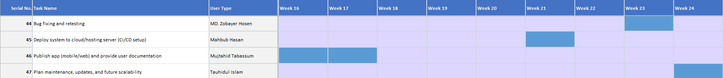

**Figure: Timeline chart for Task 44 to 47 (Week 16-24)**

**Risk Awareness and Delay Management**

Common risks include:

* **Unrealistic deadlines**: Avoid by accurate estimation (COCOMO + conventional).
* **Changing requirements**: Managed by Scrum (backlog updates).
* **Technical risks**: Prototype early in Month 4.
* **Human issues**: Cross-training members.
* **Miscommunication**: Daily standups, clear Trello board updates.

By planning for these risks, we improve the chance of meeting deadlines successfully.

# SOFTWARE DESIGN

**4.1 System Design**

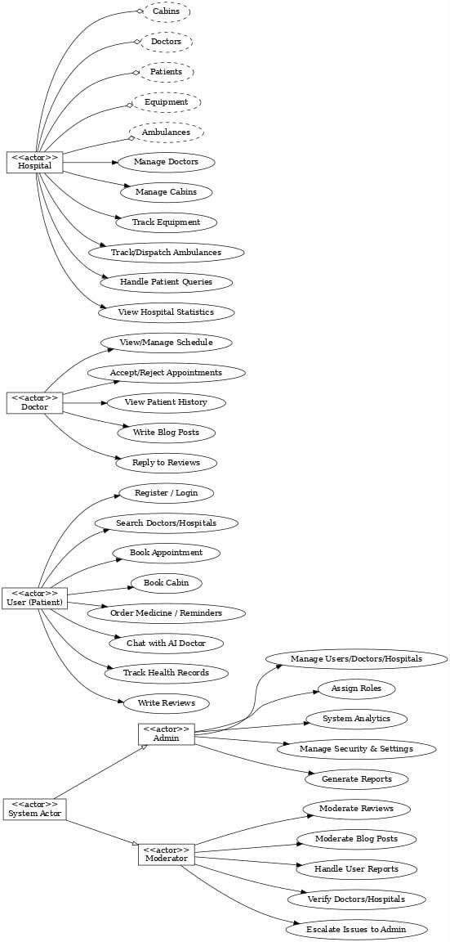

**Figure: Use case Diagram**

**Figure: Class Diagrams**

**Figure: Class Diagrams**

**Figure: Class Diagrams**

**Figure: Class Diagrams with relationships**

**Figure: Activity Diagram**

**Figure: Sequence Diagram**

## UI / Wireframe Design

**Admin User Role**

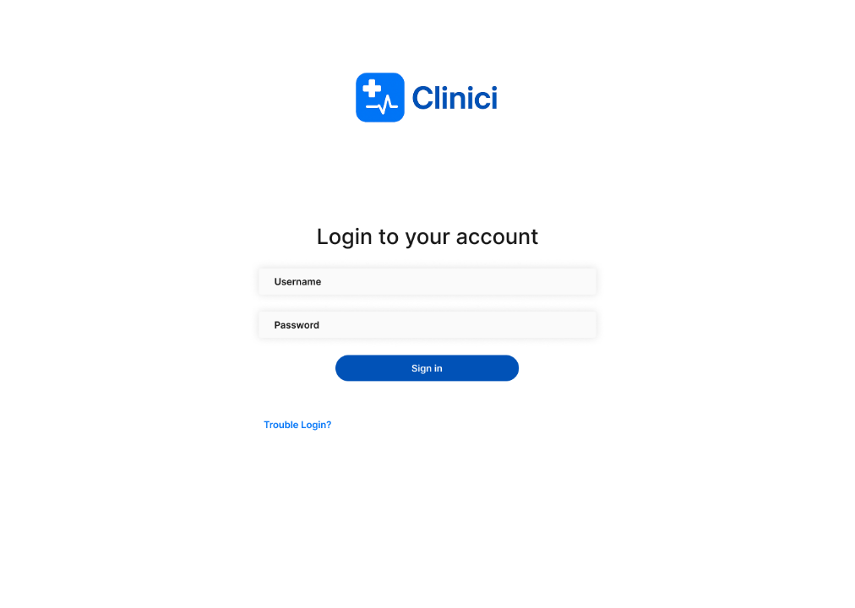

**Figure: Admin Login**

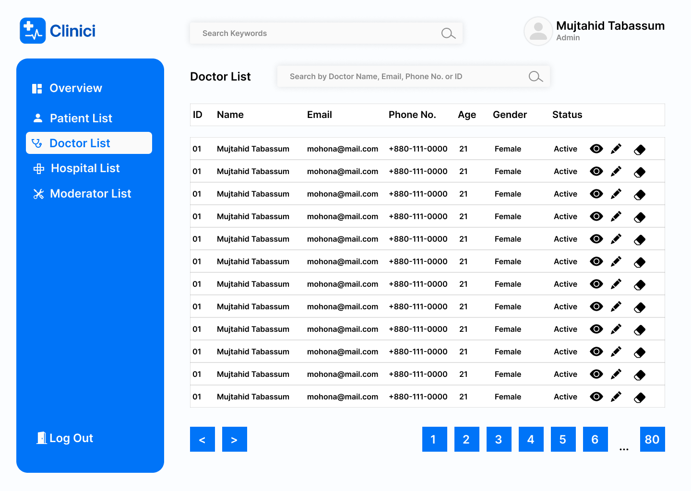

**Figure: Admin – Doctor List**

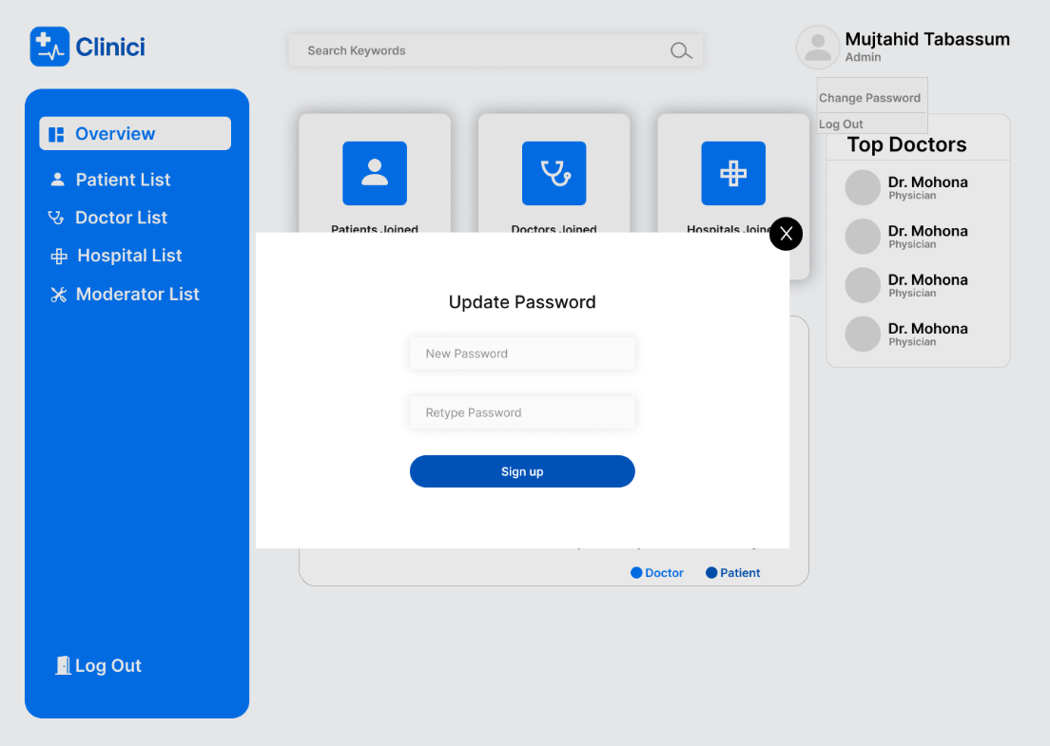

**Figure: Admin – Update Password**

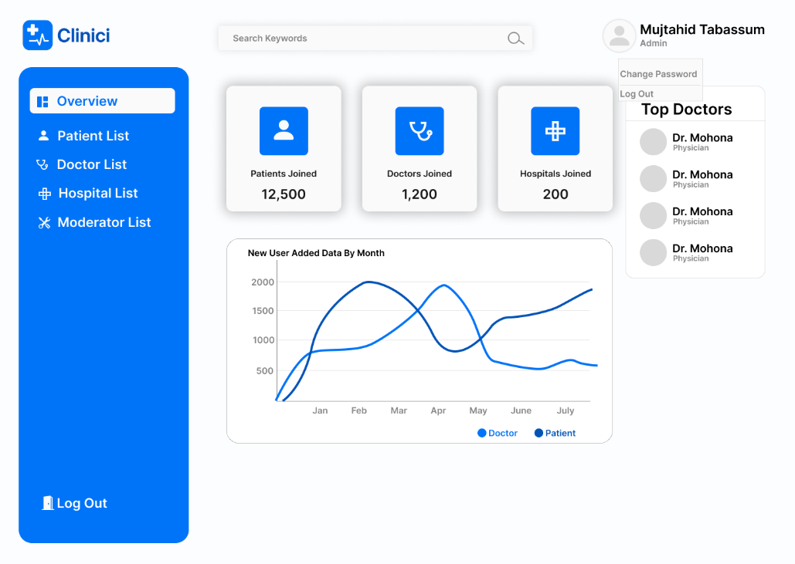

**Figure: Admin – Overview**

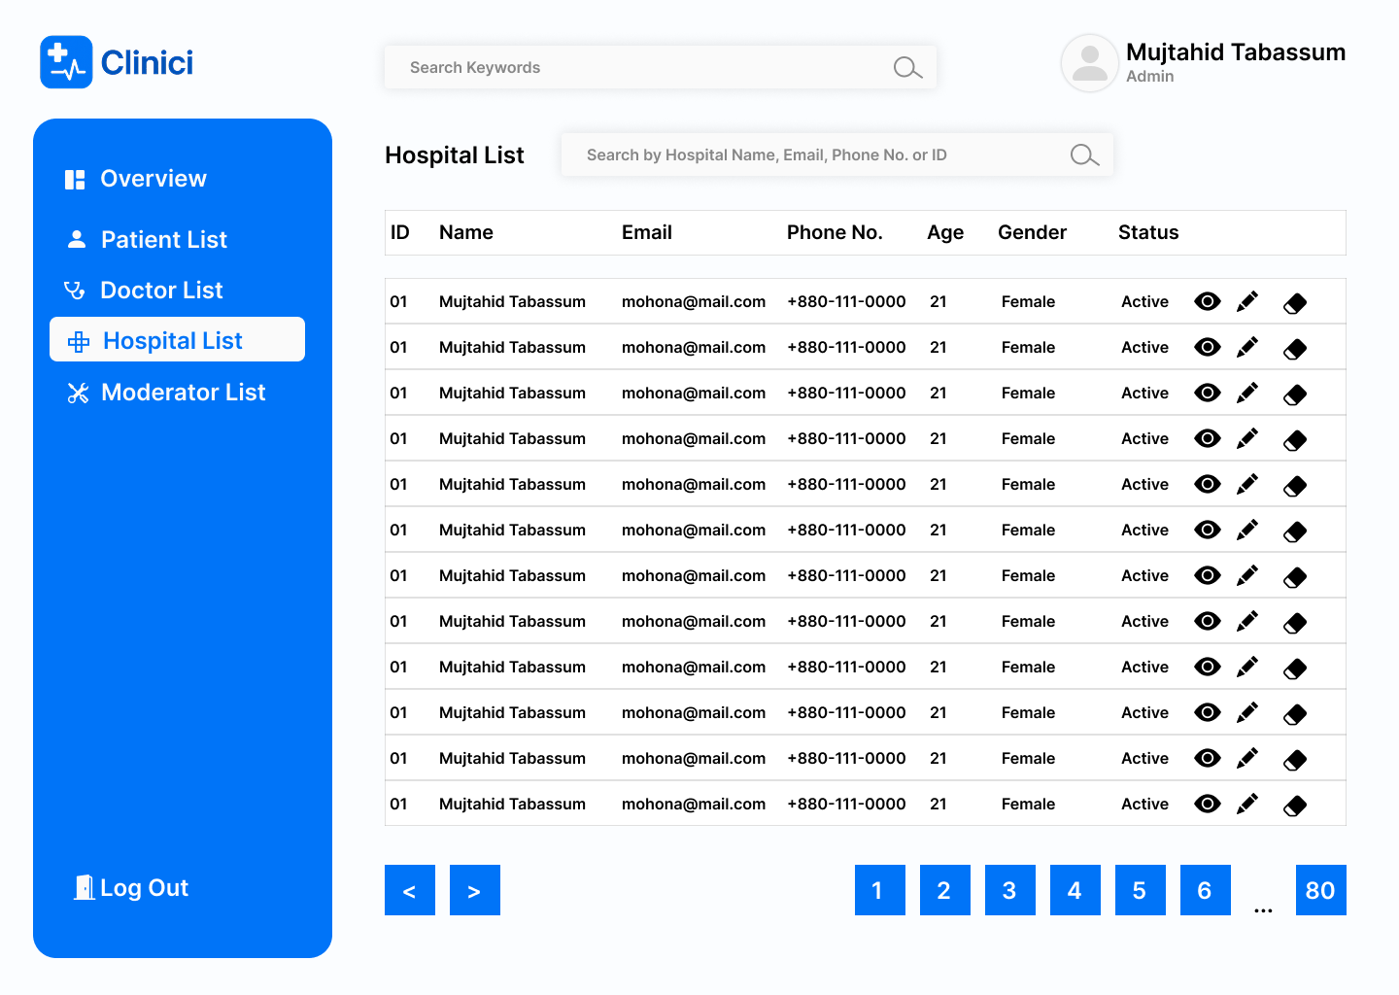

**Figure: Admin – Hospital List**

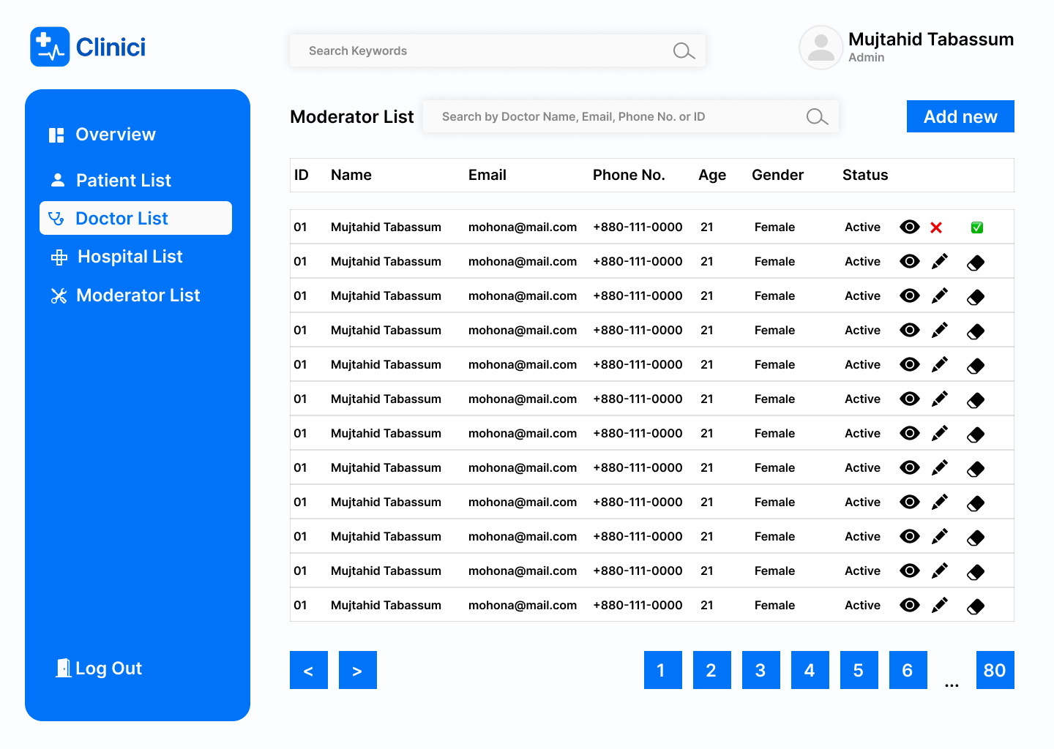

**Figure: Admin – Doctor List (First List Selected)**

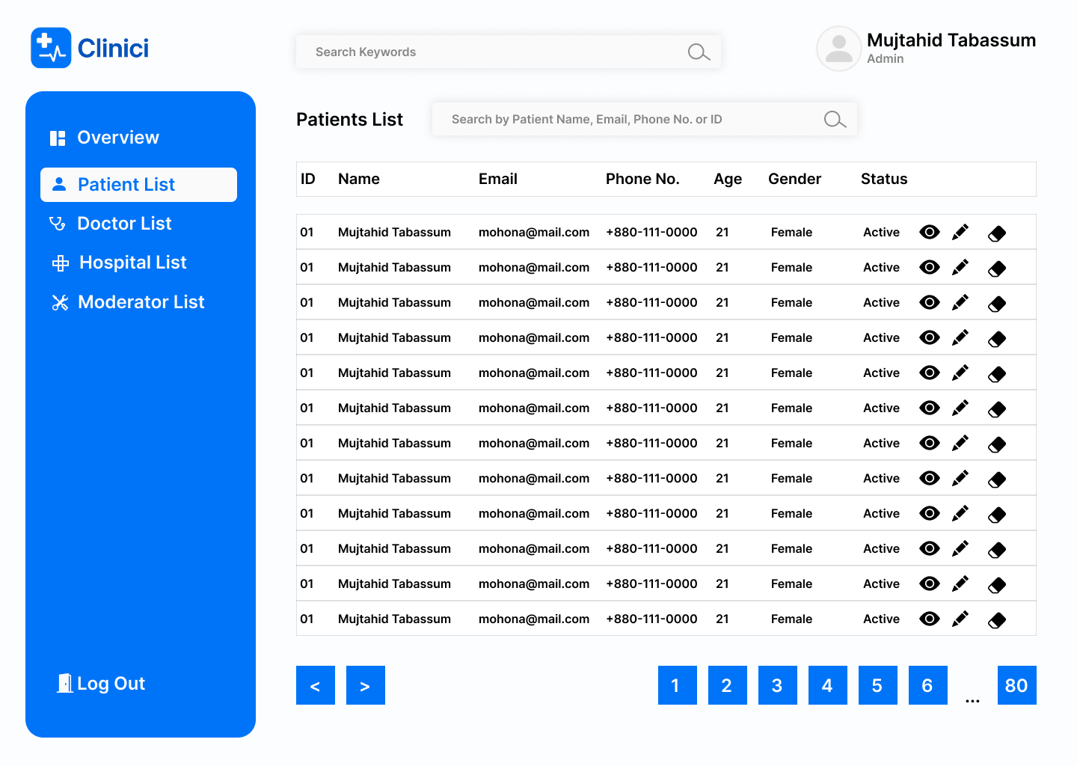

**Figure: Admin – Patient List (First List Selected)**

**Mobile App first time open User Interface (Patient, Doctor and Hospital user role):**

 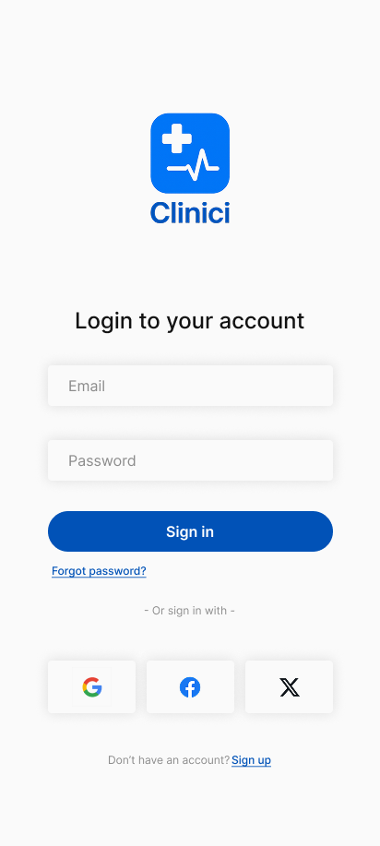 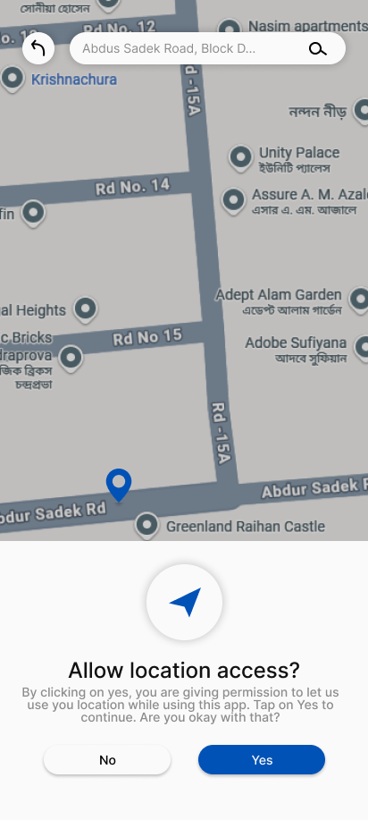

**Patient User Role**

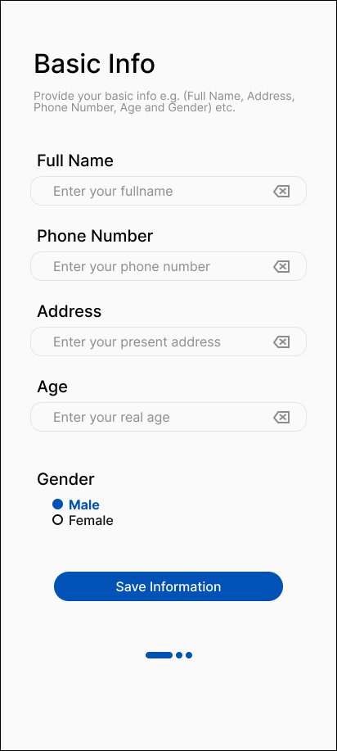 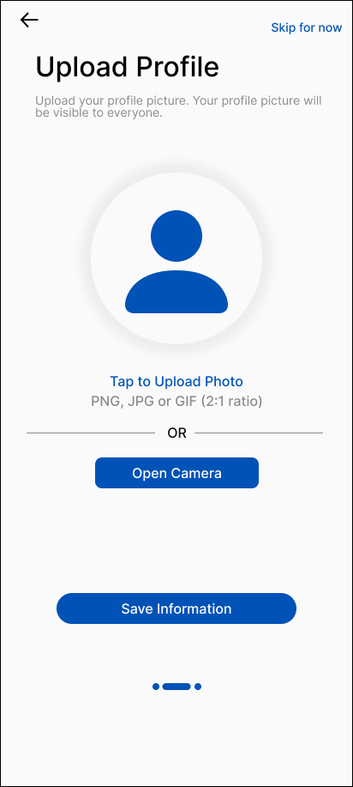 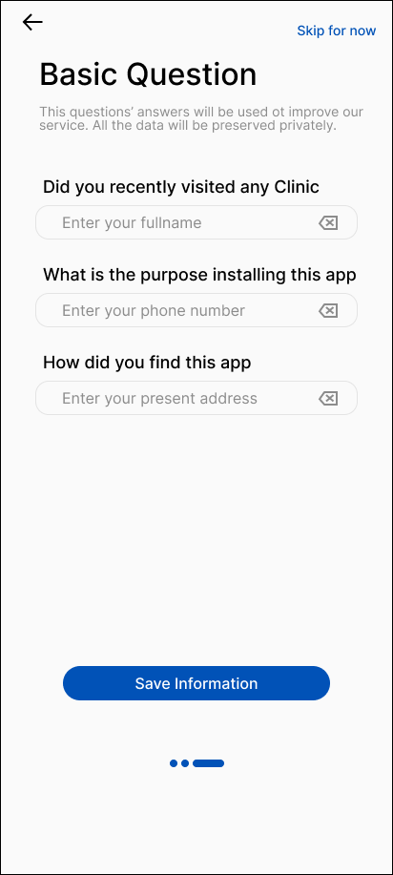

**Figure: Filling up basic information**

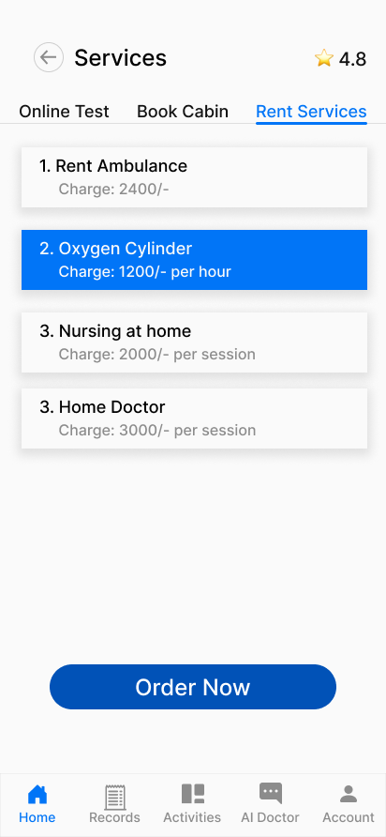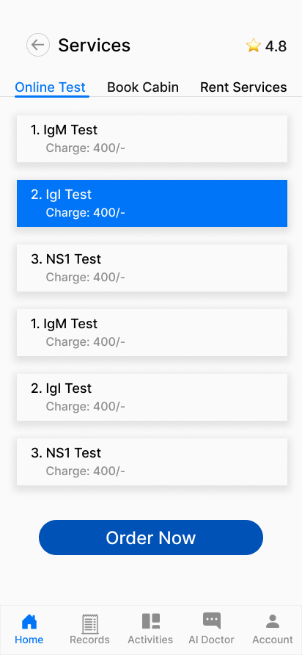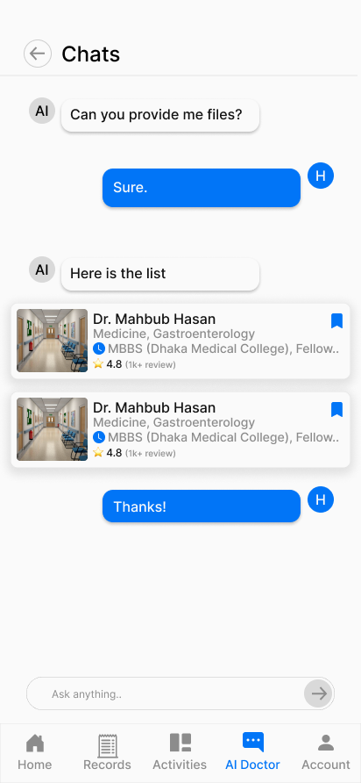

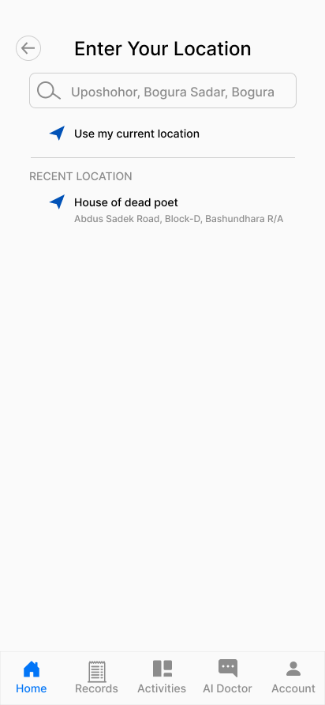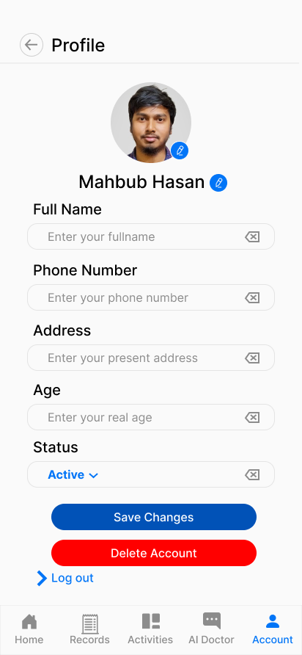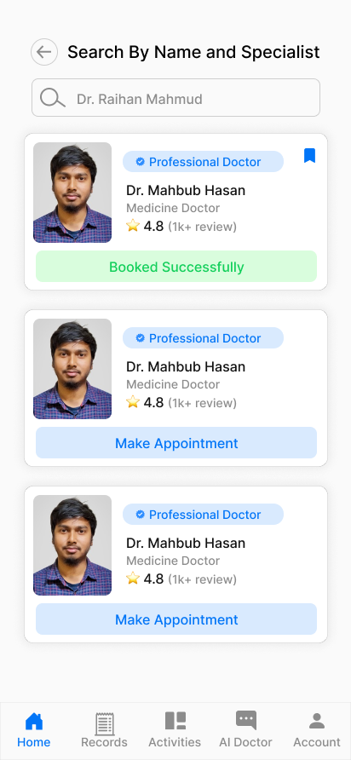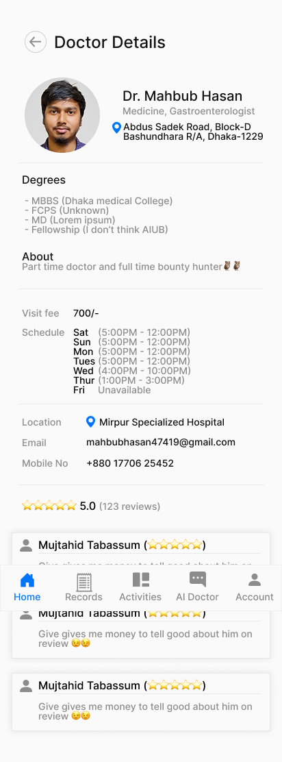

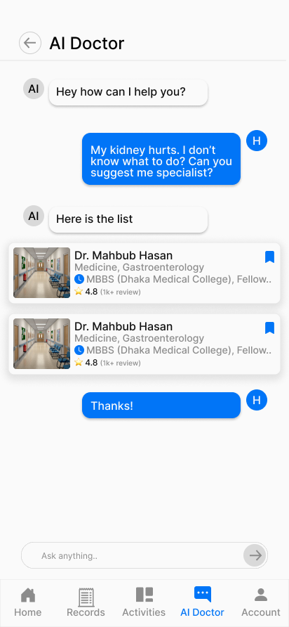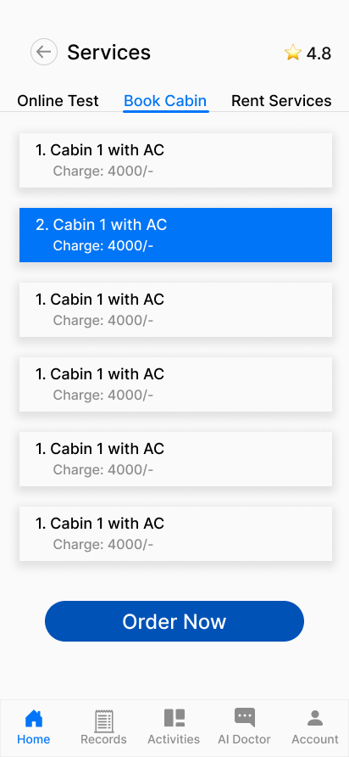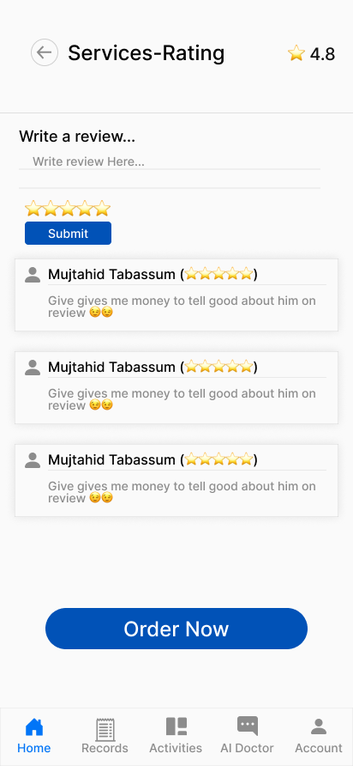

**Figure: Patient User Role All User Interfaces**

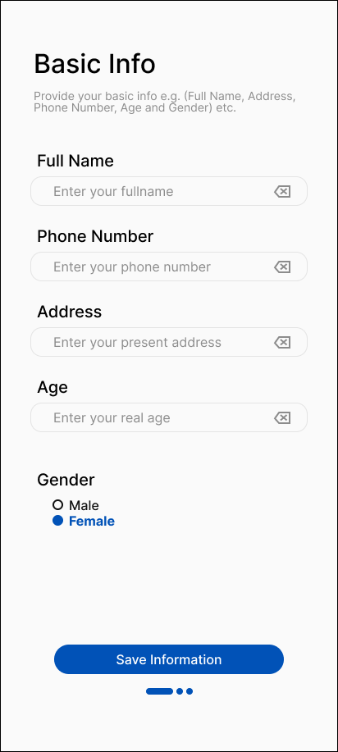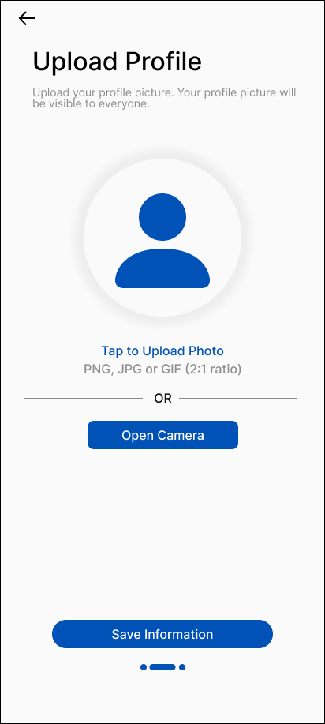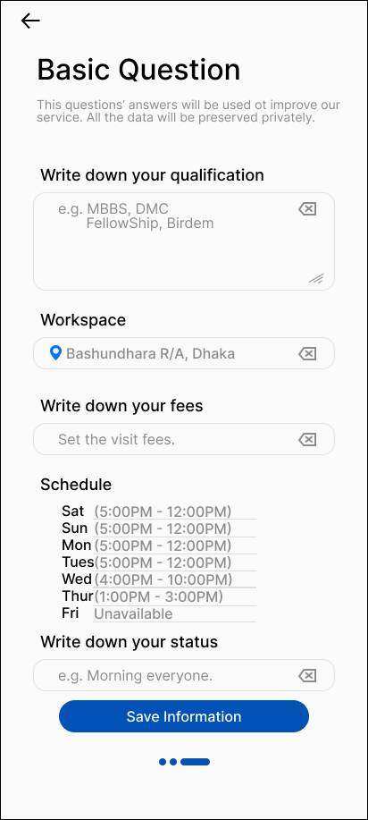

**Figure: Filling up basic information**

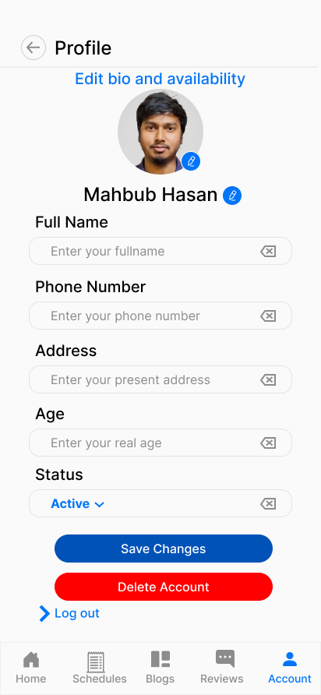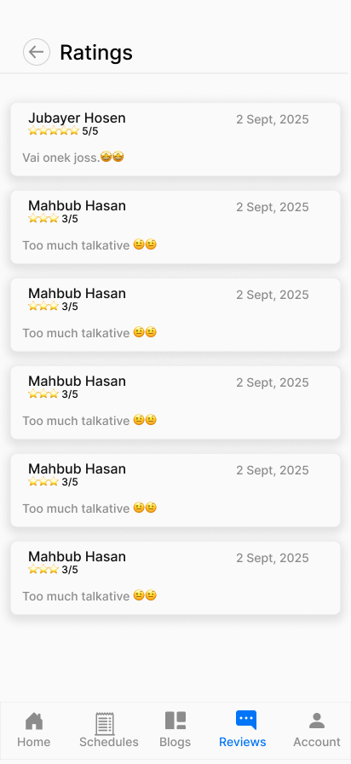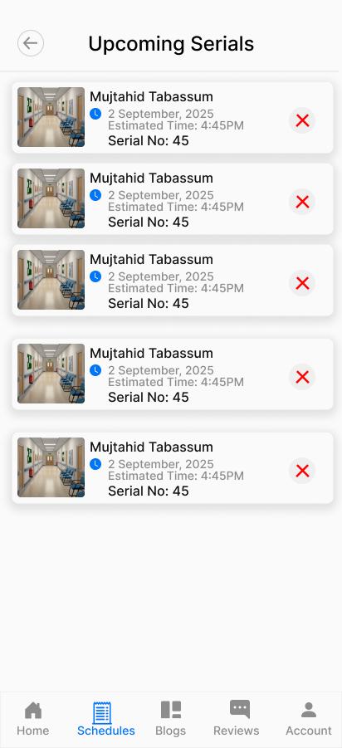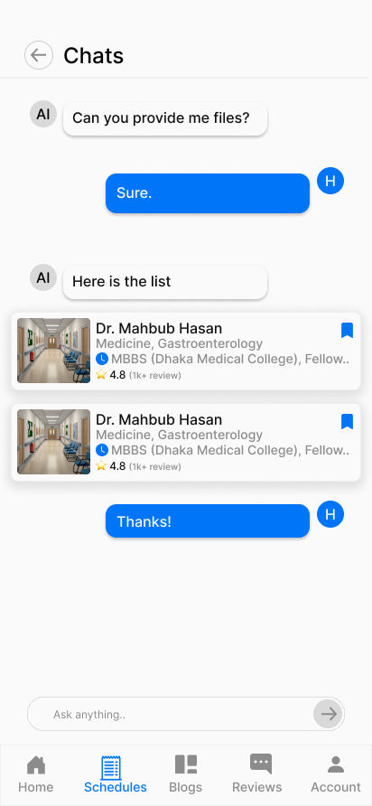

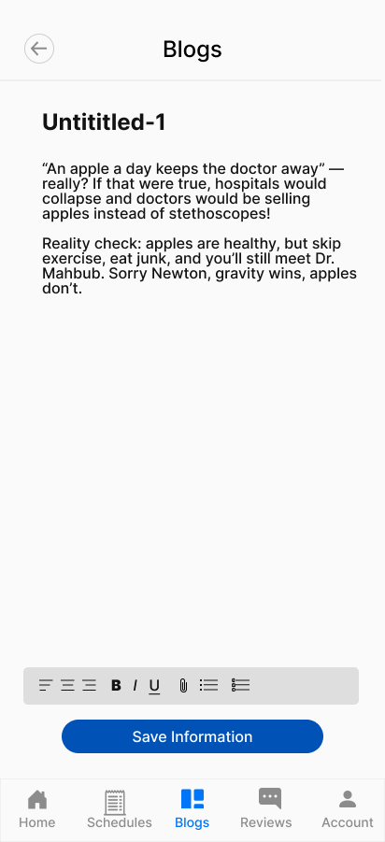

**Figure: Doctor User Role All User Interfaces**

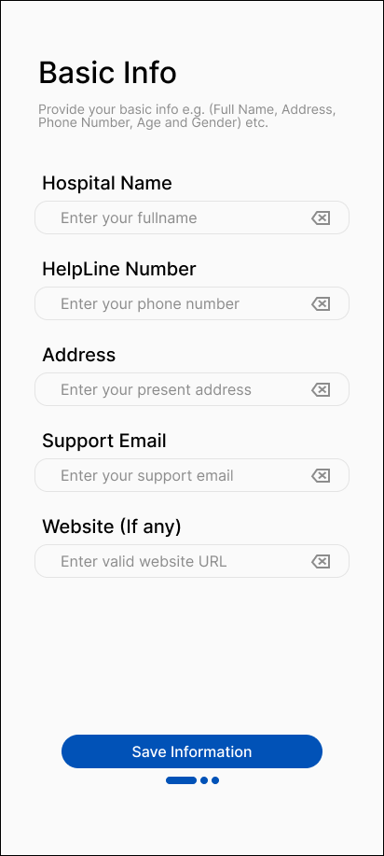 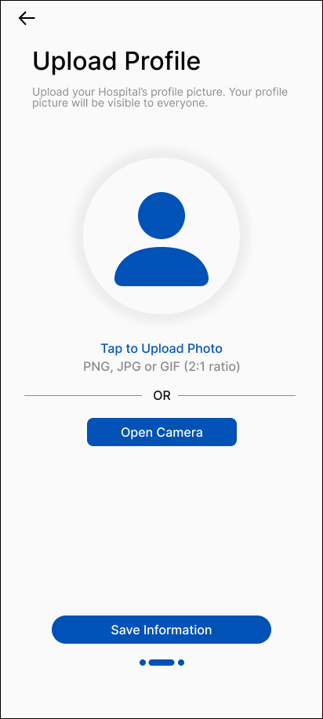

**Figure: Filling up basic information**

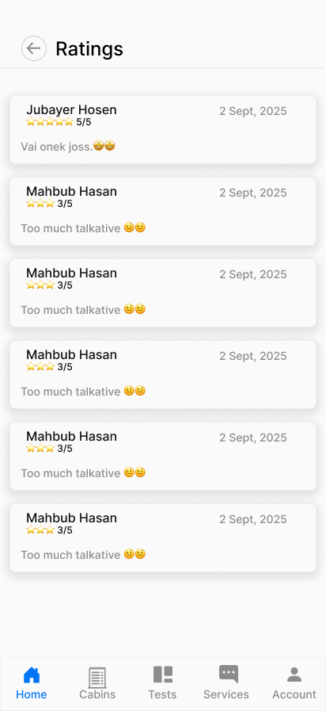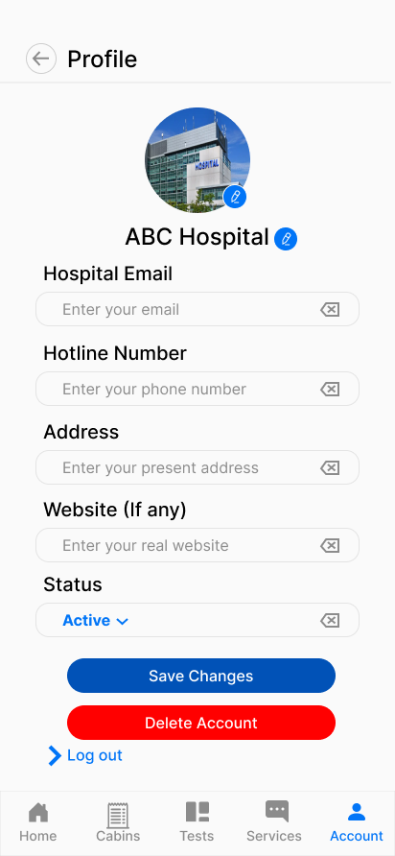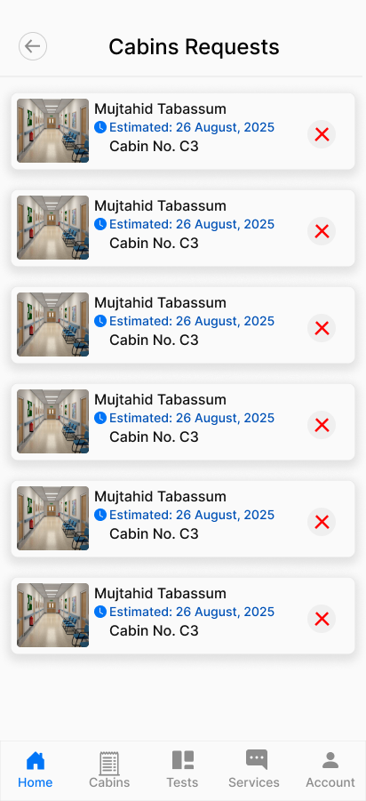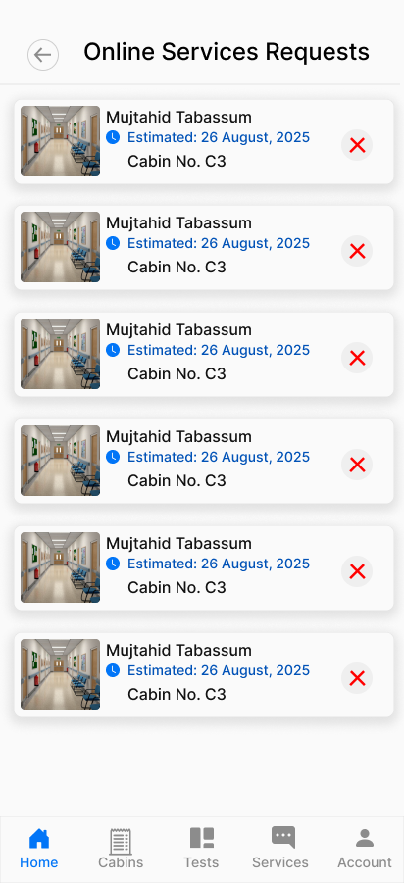

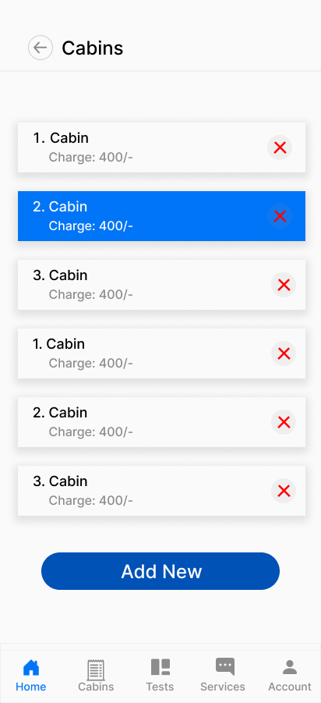 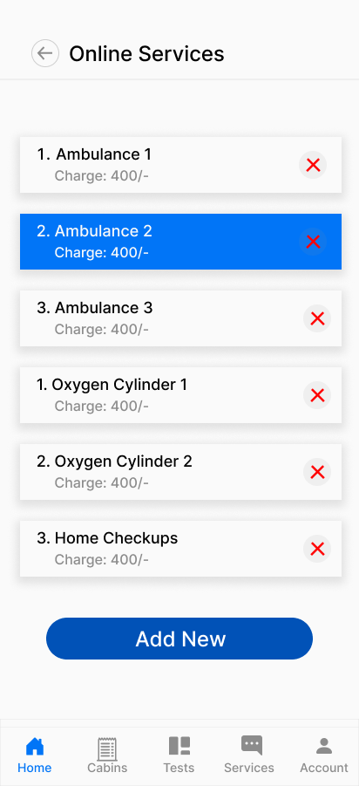 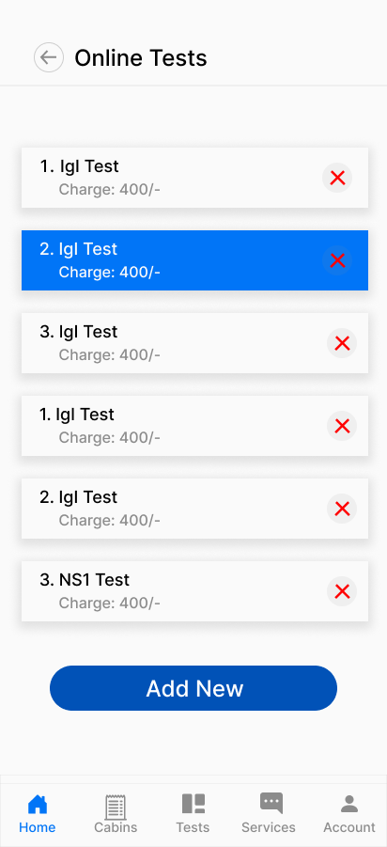

**Figure: Hospital User Role All User Interfaces**

# GIT WORKFLOW

* Create a central repository for the project on GitHub and set the **master (or main) branch** as the primary branch for integration.
* Each member should clone the repository and create their own **feature branches** for assigned tasks. Work on new features or fixes within these branches.
* Add files, stage them and commit changes with clear messages that describe the purpose of each update.
* Push commits from the feature branches to the remote repository so other members can see progress.
* Use **pull** to fetch and integrate changes from the remote repository into local copies, ensuring everyone stays updated.
* Merge feature branches into the **master/main branch** only after the work is tested and reviewed, resolving any conflicts that occur.
* Show evidence of collaboration by maintaining a clear commit history (using logs) with multiple commits, merges and contributions from all group members.
* Keep the repository organized with a clean history that tracks the project workflow from initialization to completion.

# RISK MANAGEMENT

**Risk Table - Online Hospital Management and Service Booking System**

|  |  |  |  |  |
| --- | --- | --- | --- | --- |
| **Risks** | **Category** | **Probability** | **Impact** | **RMMM** |
| System complexity may be significantly high | PS | 60% | 3 | Build incrementally, modular design |
| Database design will be complex | PS | 50% | 3 | Use proven patterns, test early |
| Healthcare regulations not followed | BU | 70% | 4 | Legal consultation, encrypt data |
| Hospital partnerships will fail | BU | 60% | 3 | flexible APIs |
| End-users resist system adoption | CU | 50% | 2 | Simple interface, local language support |
| Payment integration will fail | TE | 40% | 3 | Multiple gateways, test thoroughly |
| Real-time features won't work | TE | 30% | 2 | Use reliable technology, load testing |
| Team lacks healthcare knowledge | ST | 70% | 3 | Hire domain expert, train team |
| Staff size insufficient for scope | ST | 50% | 3 | Plan resources, consider outsourcing |
| Security vulnerabilities will exist | DE | 60% | 4 | Encryption, access control, audit logs |
| Home service delivery will fail | Operational | 60% | 2 | Partner with logistics, GPS tracking |
| System downtime during emergencies | Operational | 40% | 4 | Backup servers, 24/7 monitoring |

Impact Values:

* 1 — negligible
* 2 — marginal
* 3 — critical
* 4 — catastrophic

*The work product is called a Risk Mitigation, Monitoring, and Management Plan (RMMM)*

# TESTING

* The goal is to show how testing ensures quality and requirements conformance.
* Identify some testing methods that you want to use in the testing phase later for your project.
* Prepare **test cases** using a manual test case template which template taught you in the class.

# SOFTWARE PRODUCT METRICS

|  |  |  |  |  |  |  |  |
| --- | --- | --- | --- | --- | --- | --- | --- |
| **Information Domain Value (FP unadjusted)** | **count** |  | **simple** | **Average** | **Complex** |  | **Total** |
| Number of external inputs (EIs) | 10 | * | 3 | 4 | 6 | = | 40 |
| number of external outputs (EOs) | 7 | * | 4 | 5 | 7 | = | 35 |
| Number of external inquiries (EQs) | 5 | * | 3 | 4 | 6 | = | 20 |
| Number of external inquiries (EQs) | 8 | * | 7 | 10 | 15 | = | 80 |
| Number of external interface files (EIFs) | 2 | * | 5 | 7 | 10 | = | 14 |
|  |  |  |  |  |  |  | 189 |

# CONCLUSION AND FUTURE WORK

**Conclusion**

This project was developed to address a real problem in Bangladesh, especially in Dhaka city, where patients often face difficulties in booking doctor appointments, managing hospital services, or accessing health reports on time. The proposed Hospital Management System provides a single digital platform where patients, doctors, and hospitals can connect easily. Patients can book appointments, track serials, order tests from home, and rent medical equipment. Doctors can manage their schedules, interact with patients, and share health blogs. Hospitals can manage beds, tests, and equipment in a more efficient way. An AI Doctor feature was also included to provide primary guidance to patients before they consult real doctors.

By following the Agile Scrum methodology, the development process was organized into sprints that helped in managing tasks, handling requirement changes, and ensuring teamwork. The solution provides efficiency, time saving, and accessibility in the healthcare system. It also reduces miscommunication between patients, doctors, and hospitals.

**Future Work**

Although the system achieves its main objectives, there are still areas for improvement and expansion. In the future, the project can be extended with:

1. AI Doctor Enhancement – Using more advanced machine learning models trained with local medical data to provide safer and more accurate initial suggestions.
2. Telemedicine Feature – Adding secure video consultation between patients and doctors to reduce travel and waiting time.
3. E-Prescription System – Doctors can prescribe digitally, and patients can directly order medicines from nearby pharmacies through the app.
4. Integration with Government Databases – For verifying doctors’ licenses, hospitals’ registrations, and ensuring patient data privacy in line with local regulations.
5. Scalability Across Bangladesh – Expanding the system from Dhaka to other major cities and rural areas, ensuring better healthcare access for people outside the capital.
6. Multilingual Support – Adding Bangla as the main interface language so that rural patients can use the system comfortably.
7. Data Analytics – Using big data to generate insights for hospitals and government agencies on disease trends, patient needs, and healthcare service quality.

With these future improvements, the system can grow into a nationwide platform that not only helps patients and doctors but also contributes to building a smarter, more digital healthcare ecosystem in Bangladesh.

**Text Format:**

* Style: Times New Roman
* Size: 12
* Space: 1.15
* Alignment: Justify